Step 1: When you’re ready to have a bowel movement, take the swab collection kit with you and have it ready to use. | Step 2: After the bowel movement, use the swab in your collection kit to swab the toilet paper used to wipe with. Make sure there is sample on the swab, but not more than a half-pea size amount. | Step 3: With sample on the swab, place in tube with the clear liquid. Spin the swab ten times, the color of the liquid should be a medium tan to light brown. Break the swab stick at the line and screw on the cap.
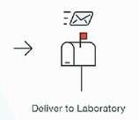 | 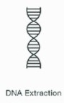
Step 4: Place your tube sample in the zip-type sealed bag and follow the instructions to send your sample to Soft Cell laboratories at 4616 S. Beehive Dr. Suite 4, Saint George Utah 84790. | Step 5: When your sample is received at Soft Cell Laboratories, we will extract the microbial DNA from your sample. Then using 16S rRNA sequencing and Bioinformatics we will identify the individual microbes of your sample. | Step 6: When processing of your sample is complete, Soft Cell Laboratories will send a comprehensive Microbiome Report to the email provided upon registered. If you have any questions call (435)628-2215 Monday thru Friday 8am to 5pm MST.

